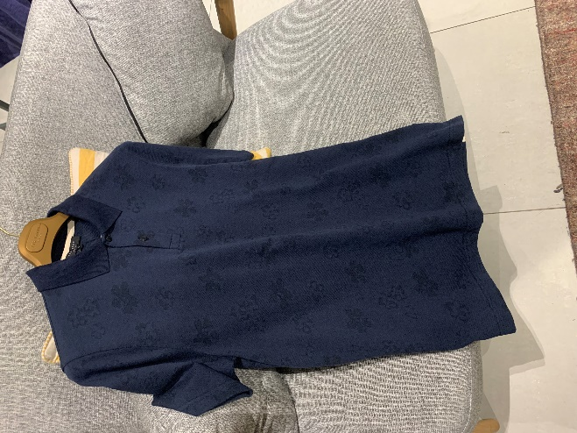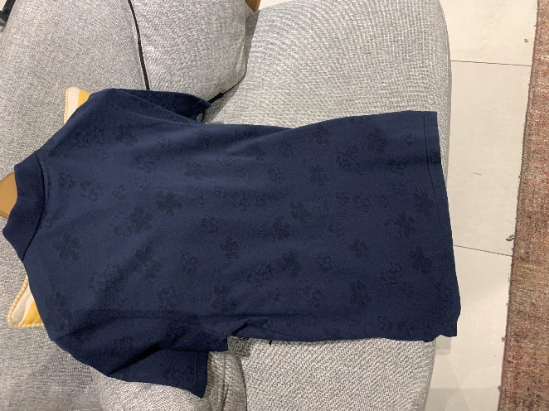

Ted Baker T-shirt comes in blue colour.

Product code: MMA11314

Price: £15.50

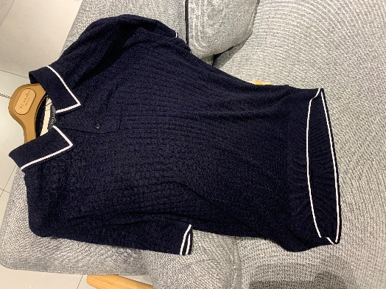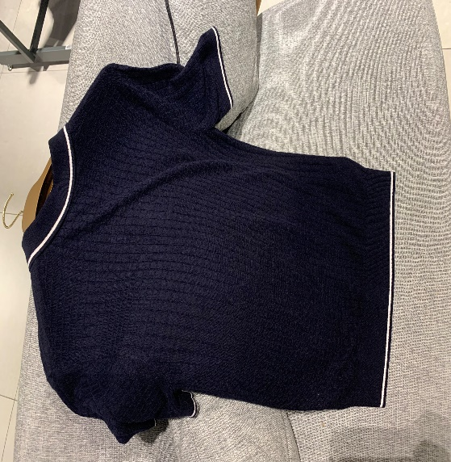

T-shirt comes in blue colour for men and to go out for BBQ.

Product code: BMM01895

Price: £8.40

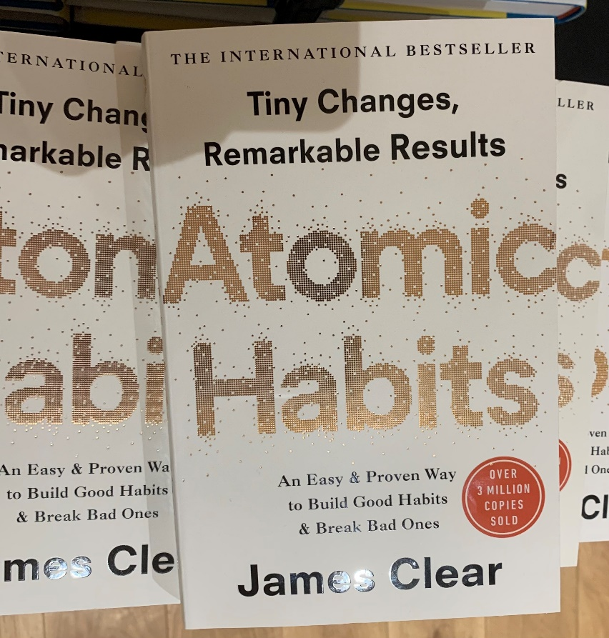

Atomic Habits: An Easy and Proven Way to Build Good Habits and Break Bad Ones.

Price: £20.80 (Handover)

Price: £8.19 (paperback)

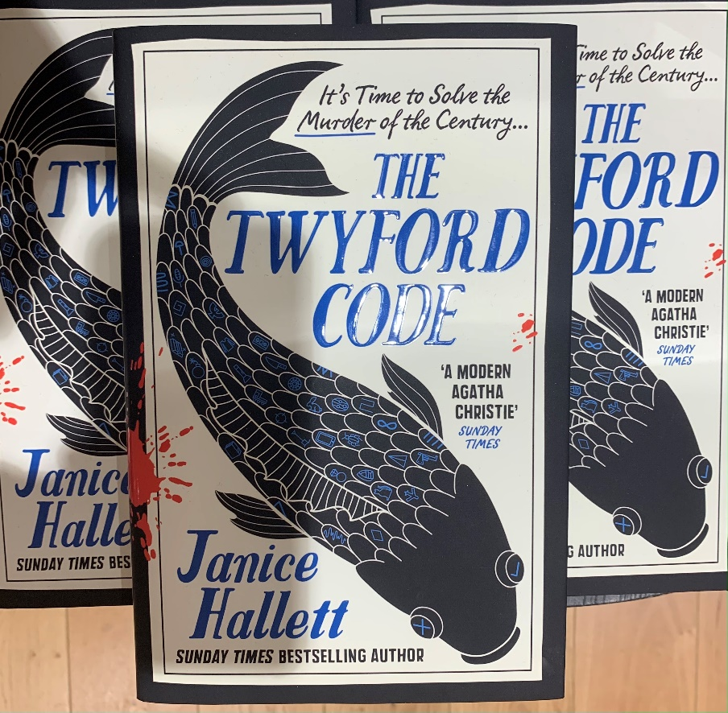

The Twyford Code: It's time to solve the murder of the century

Price: £10.0 (Handover)

Price: £7.37 (paperback)

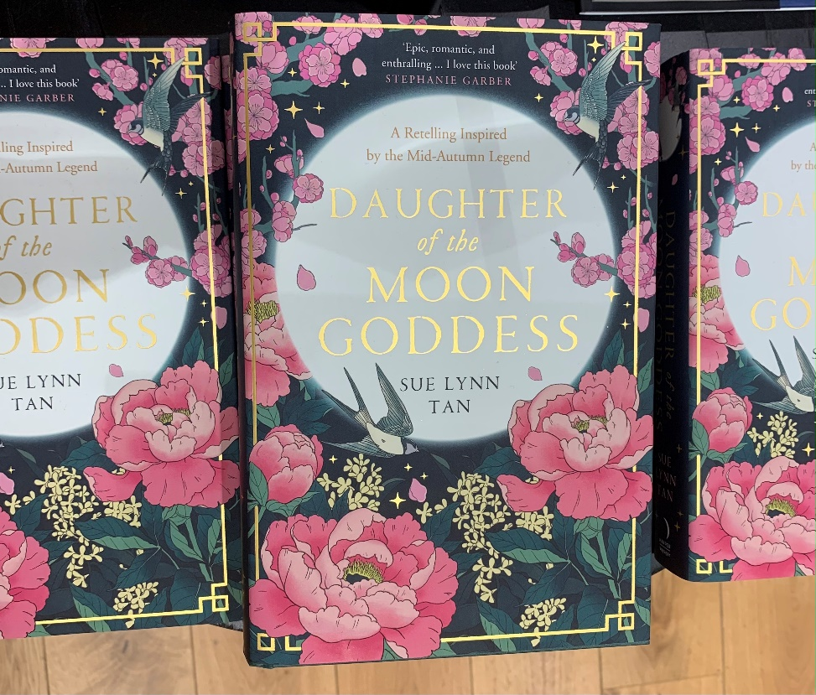

Daughter of the Moon Goddess: The Celestial Kingdom Duology.

Price: £11.99 (Handover)

Price: £7.37 (paperback)

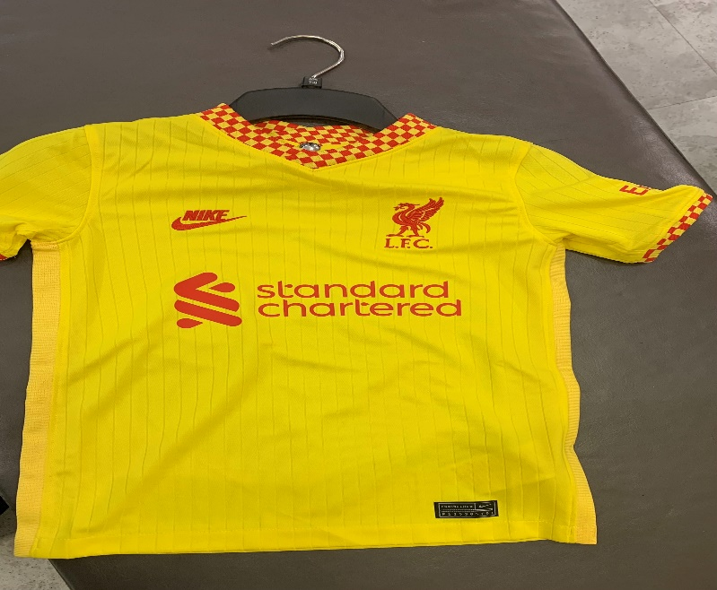

Nike Liverpool FC 2021/22 Third Shirt

£70.00

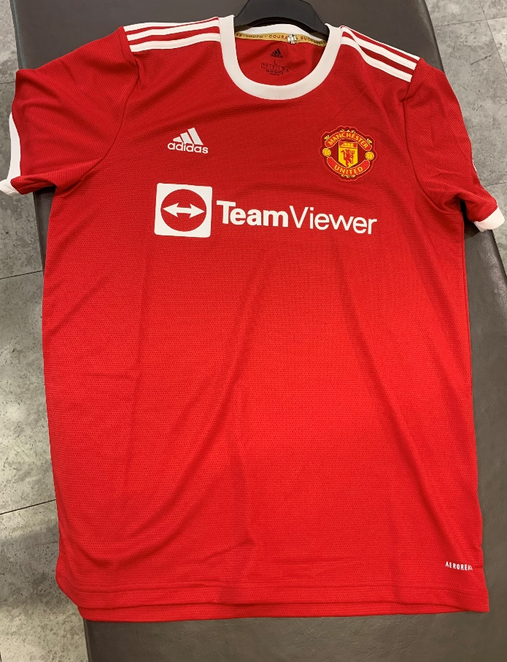

adidas Manchester United FC 2021/22 Home Shirt

£65.00

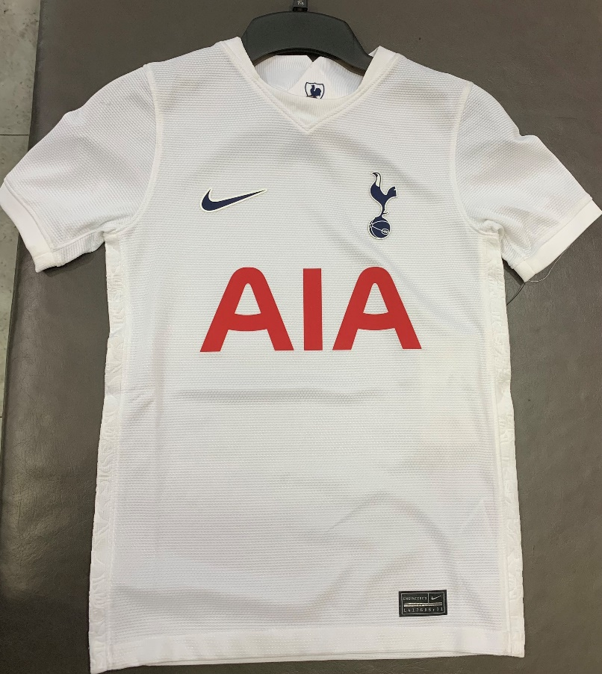

Nike Tottenham Hotspur FC 2021/22 Home Shirt

£70.00

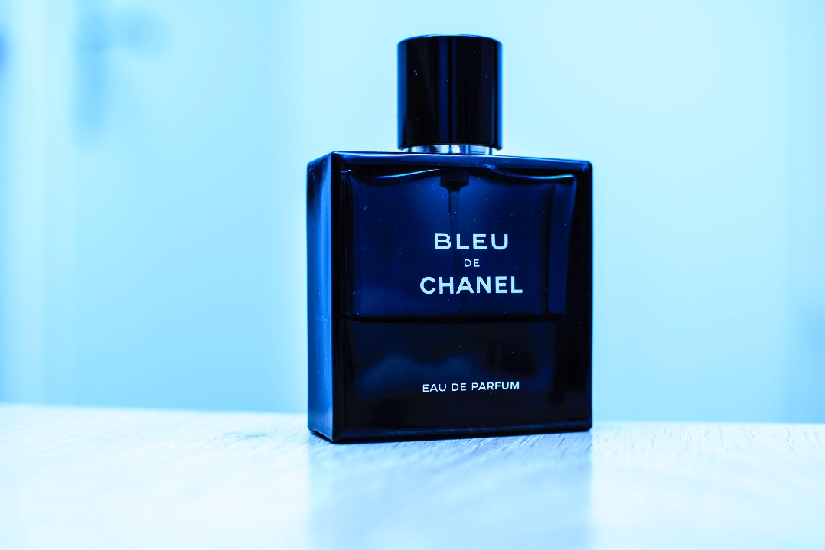

CHANEL

BLEU DE CHANEL

Eau De Toilette Spray 50ml

£61.00

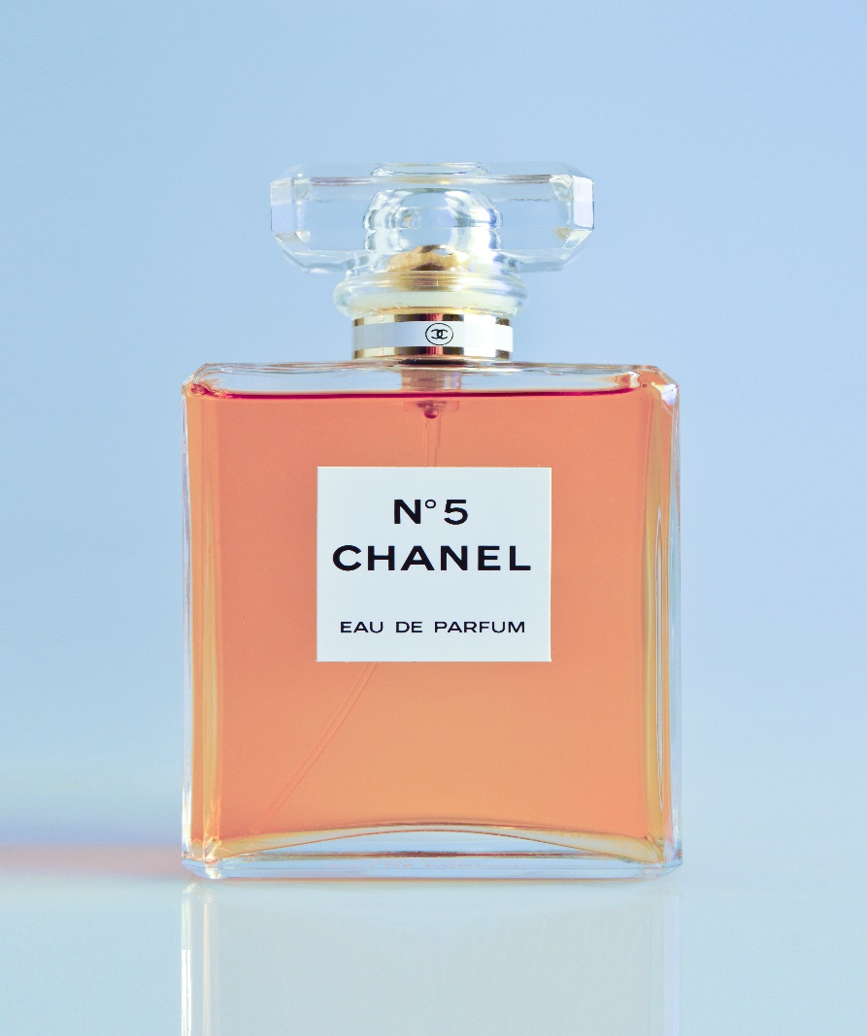

CHANEL N°5

Product code: 1003581

Eau de Parfum Spray

100ML - £120.00